SICTC FRAMES
User Instructions
Technical Documentation
Blake Brucken & Landon Meuth
User Instructions
Set a Static IP Address on your Pi
Clone Repository
Run the Bash File

Inner Workings
The HTML
The JSON
The Script
The Style
The Folders
The HTML
The HTML file, called ‘home.html’ is located under the ‘frames’ folder. It’s job is to display the Frames to the user and import the JSON, Script, and Styling files.
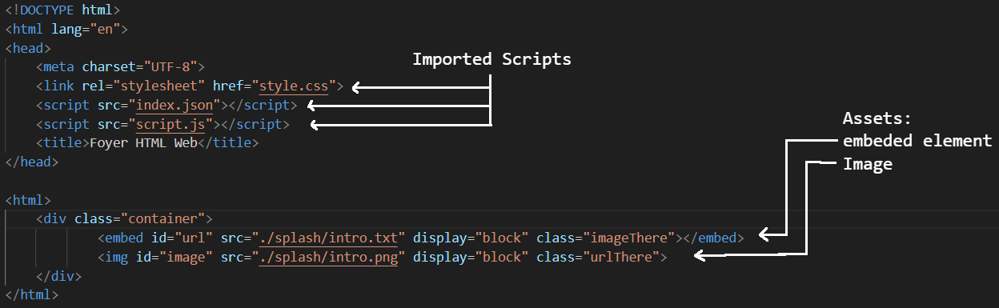
The two assets in the file has 4 inline stylings:
- id: The way this HTML tag is called inside the Script file.
- src: The source file for the tag.
  - For embed, this could be a website, image, text file, etc.
  - For img it supports image types.
- display: the display property controls if an element is present on the page.
  - “block” = show element. (I know, its confusing.)
  - “none” = hide element.
- class: tells the CSS file to format the tag based on what class it possess.
  - Example: embed has the class “imageThere”, this tells the CSS file to make the embed tag share room with the image tag. This work in conjunction with the “display” inline styling. When a new frame is loaded and the frame has no image, the Script sets display to “none” and class to “imageGone”. Now Embed is allowed to take up the entire screen.

The JSON
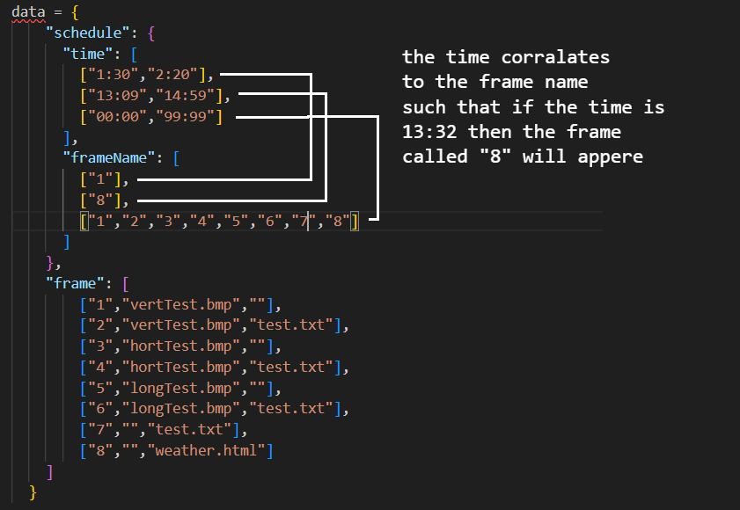
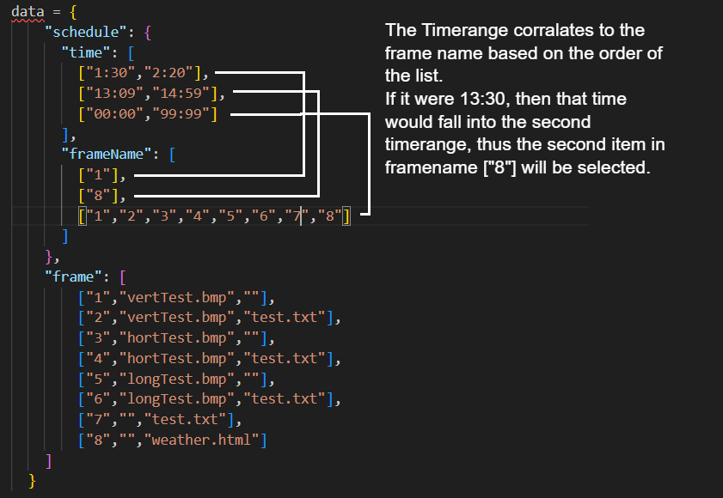
How the JSON file works: There are 2 elements in the JSON, Schedule and frame. Schedule contains time and frame name, which correlates to each other based on their position in the list (see image above). The last time frame [00:00,99:99] is intended for default frames, and it will play anytime another frame is not scheduled. Then frame contains a list formatted as such:
[“NAME”, “IMAGE”, “PAGE”]
Example: The time, 13:30 is given. This falls between 13:09 and 14:59 which is the 2nd time frame in the time list. Then the 2nd frame name is chosen, and it is called “8”. on frame, the list beginning with “8” is chosen, and the image and website referenced in the list are used to make up the new frame.
The Script

The Style
don’t touch
The Folders
There are two folders under the root of Frames: files and splash. Files contain assets that frames can use such as images, websites, text files, etc. Splash has a similar purpose for files, but it is reserved for the programs splash screen (first frame shown after program start). You may put anything inside files that you need to build your own custom frames, but splash should remain the same. If you want to change the splash screen, edit the files, but do not change their names unless you also change their reference in the HTML file (and be careful).

